Puppy Raising Department
Ruff Notes
“Here Comes the Sun”: Socializing GDB Puppies During Warm Weather
June 2022

“Feelin’ Hot, Hot, Hot!”: Tips on Keeping Cool

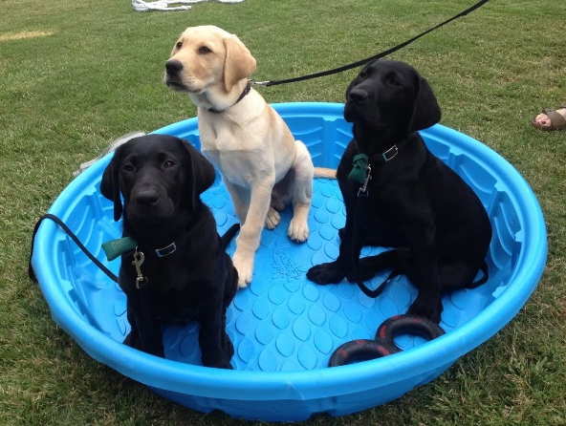

Summer is a fun time for both raisers and pups to enjoy the warm weather. There are so many creative ways to provide enrichment and socialization opportunities to puppies while also considering the higher temperatures.

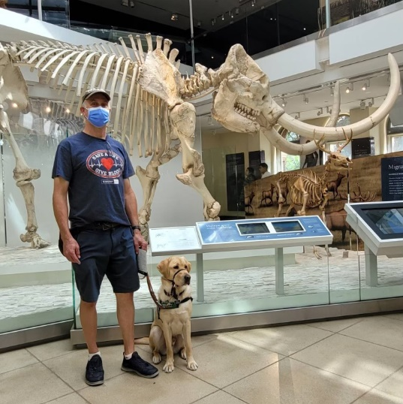
Try some of these “cool” socialization ideas:
- Kiddie pools with Jolly Balls and Nylabones
- Ice cubes in their water bowl
- Rinse down the concrete to protect puppy paws and provide a novel “surface”
- Play in the shade or during cooler times of day
- Explore indoor malls or go to the movie theater
- Check out your local museums and art galleries
- Indoor mini golf and bowling alleys

Be sure to check with your leader and Puppy Raising Field Manager (PFM) to see what socialization outings are appropriate for the puppy you’re raising!
When socializing puppies during the summer, it’s important to keep safety in mind so that the pup can have a positive experience.

Here are some summer safety tips to keep socialization fun for everyone:
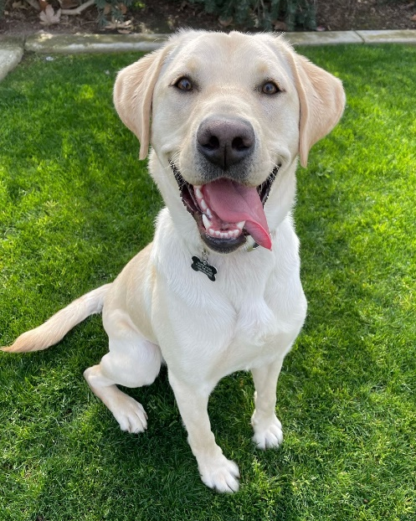
- Always check the temperature of the ground prior to taking a pup out - if your hand can comfortably stay on the surface for 5+ seconds, then it’s safe for a puppy’s paw pads
- In warmer areas, try socializing puppies during cooler times, like earlier in the day or after the sun goes down
- If you’re considering bringing a puppy to a pool, lake, or other water source, please review the Swimming and Wading & Watercraft Guidelines before heading out
- To keep puppies comfortable when riding in vehicles, turn on the A/C prior to having them enter
- Have fresh, clean water available at all times and bring some with you if you’re out and about
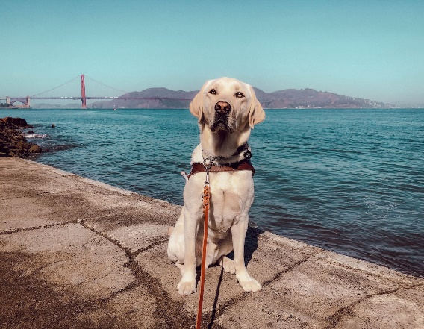

If you have questions about using booties with a pup you’re raising, please reach out to your leader and PFM.

“Baby, You’re a Firework!”: 4th of July Considerations

Watching a firework display can be a lot of fun for us humans, but it can easily be scary for puppies. Currently, guide dog puppies are not allowed to attend firework displays and should stay indoors during firework festivities.

We want to keep guide dog puppies safe and comfortable during this loud celebration.
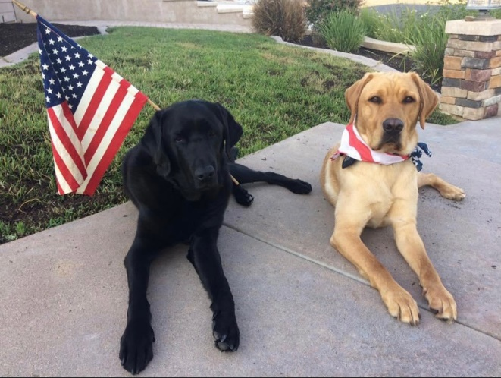
Here are some ideas to helping puppies stay relaxed this 4th of July holiday:
- Puppies should stay indoors
- Relieve puppies prior to anticipated firework time
- If left at home alone, pups should be crated in a quiet room
  - Here’s a tip: Turn on the TV or radio to drown out the noise
- All puppies should be wearing their flat collar and tags

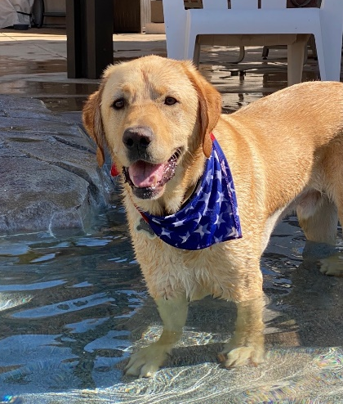

Share pictures of your summer socialization with GDB puppies on social media using #GDBBeatTheHeat and don’t forget to tag us!

