Puppy Raising Department
Ruff Notes
Walking into the New Year: Getting Guide Dog Puppies Fit for Recall – December 2021
Did the GDB puppy you are raising eat too many snacks over the holiday season? It’s easy to over-indulge when you’re having fun! The New Year is a great time to re-evaluate and set goals for ourselves and guide dog puppies. A good New Year’s resolution is to make sure that the puppy you are raising is fit for recall and to know how to evaluate body condition.
New Year’s Resolutions: Assessing BCS
In Puppy Raising, you’ll frequently hear something called BCS, but what is BCS? This refers to a “Body Condition Scoring” system to identify the overall condition and fitness of a dog. It is crucial that program dogs remain physically fit for several reasons, including meeting the physical requirements of guidework and reducing the frequency of injury while working.

For all dogs in our program - from puppies to guide dogs - an ideal and healthy BCS is between 4 & 5 (see diagram below).
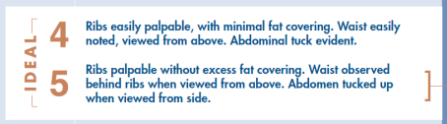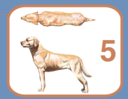
Monthly reports are a great time to evaluate BCS!

Steps to Evaluating BCS
- Start by having the puppy in a standing position.
- Observe the puppy from an aerial view to evaluate waistline.
- Run hands down the length of the puppy’s side, from shoulders to hind legs, to evaluate fat covering the ribs and abdominal area.
- Take a step back to view the puppy’s side profile to examine abdominal tuck. This may be easier with another handler assisting.
Here’s a tip! If you’re evaluating BCS alone, try using the paw pad to keep the pup in place.

Other things to note while evaluating:
- Does the puppy have additional fat on the chest or abdomen area?
- Are their hip bones or lower ribs protruding?
- Body type will vary between each dog - some may be leaner in build while others are more muscular
- Friends and family may comment that the puppy you are raising is too lean. This is a great time to remind family and friends that the puppy is preparing to become a working dog that may have different body condition requirements than a pet dog.

NOTE: If you have concerns about the puppy’s BCS, contact your leader or CFR for guidance.

Let’s get down to fitness

Whether the puppy you’re raising is already physically fit or they need to reach an appropriate BCS, there are many ways to stay active! Make sure that whatever activity you choose is age appropriate for the pup:
- Neighborhood walks
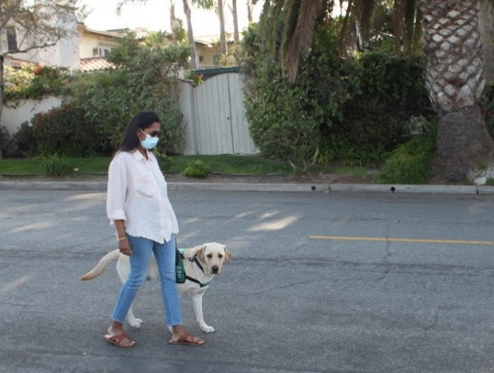
- Short hikes- Note: be mindful about relieving concerns on hikes! Doggy smells and vegetation can cause unwanted relieving, so always make sure the pup is relieved prior to the hike.
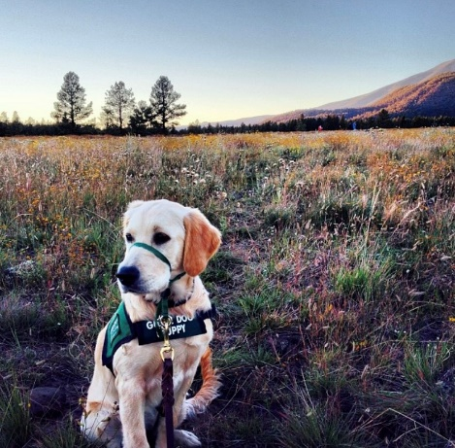
- Yard play
- Tug or playing with toys
- Interactive play with raiser - Hide and Seek
- Appropriate play with other dogs
- Swimming
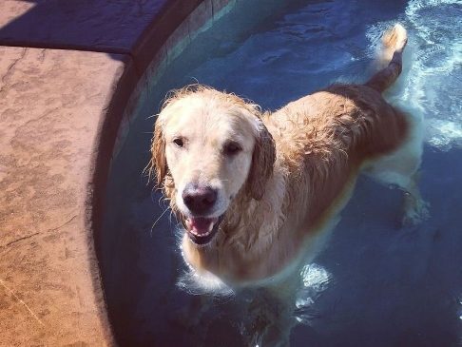
Let’s get Physical, Physical...with Canine Conditioning Games

For puppies 12 months and older, they can participate in GDB’s Canine Conditioning Games that help prepare puppies for recall and improve overall physical fitness. These exercises were designed to engage dogs both physically and mentally and vary by area of focus and degree of difficulty.

The best part? These games are fun for both raisers and dogs!

Ask your leader or CFR if you have questions on how to implement these games into the guide dog puppy’s new fitness routine!

Note: Please remember to document the pup’s participation with Canine Conditioning Games in the comment section on your monthly reports!

