May 24, 2021

To Whom It May Concern:

[Client Name] of [City, State] and [his/her] guide dog “[dog name]”, a [sex Color Breed], ID# [XXXX] (chip# XXXXXXXXXXXXXXX) are graduates of Guide Dogs for the Blind.

This team has completed a course of instruction in accordance with standards set forth by the International Guide Dog Federation. The team graduated from our [campus city, state] facility on [graduation date], having completed training under the supervision of our Guide Dog Mobility Instructors and demonstrating that they are a safe and effective team.

This new partnership would be jeopardized by not allowing [Client Name] to return directly to [his/her] home to complete the quarantine period.

Thank you for your consideration in this matter.

Sincerely,

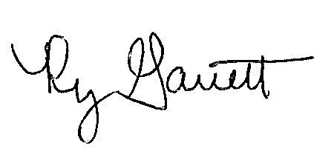

Ryan Garrett

Admissions Manager

[rgarrett@guidedogs.com](mailto:rgarrett@guidedogs.com) | (415) 499-4009

Guide Dogs for the Blind

350 Los Ranchitos Road, San Rafael, CA 94903